Final Year Project Report
IOT BASED AIR QUALITY INDEX METER SYSTEM

Submitted by:
Huzaifa Shahbaz
21-CE-009
Aqsa Shah 21-CE-039
Supervisor Name:
MAAM SARA TEHSIN
LECTURER
Dated:
21st Jan 2025
Department of Computer Engineering,
HITEC University, Taxila

Table of Contents
ABSTRACT: 5
CHAPTER#1 INTRODUCTION 7
1.1INTRODUCTION: 7
1.2 OBJECTIVES: 7
1.3 PROBLEM STATEMENT: 8
CHAPTER#2 LITERATURE REVIEW/BACKGROUND 8
2.1 LITERATURE REVIEW/BACKGROUND: 8
CHAPTER#3 PROPOSED WORK/METHODOLOGY 13
3.1 PROPOSED WORK/METHODOLOGY: 13
3.2 METHODOLOGY: 14
CHAPTER#4 RESULTS 19
4.1 RESULTS: 19
4.2 ENVIRONEMT: 19
4.2.1 HARDWARE TOOLS: 19
4.2.2 SOFTWARE/DEVELOPMENT TOOLS: 20
4.2.3 SETUP DETAILS: 21
4.3 DATASETS: 21
4.3.1 MATLAB: 21
4.3.1.1 MQ-GAS SENSORS(MQ-5 AND MQ-135) MATLAB CODE: 21
4.3.1.2 PM SENSORS(PM2.5 AND PM10) MATLAB CODE: 24
4.3.1.3 MICROCONTROLLERS(ESP32,ESP8266 AND ARDUINO UNO) MATLAB CODE: 25
4.3.1.4 AQI TABLE INDEX MATLAB CODE: 29
4.3.2 PYTHON: 31
4.3.2.1 AIR QUALITY INDEX PYTHON CODE: 31
4.4 EXPERIMENTATION: 33
4.4.1 MATLAB: 33
4.4.1.1 MQ-GAS SENSORS(MQ-5 AND MQ-135) MATLAB RESULT: 33
4.4.1.2 PM SENSORS(PM2.5 AND PM10) MATLAB RESULT: 34
4.4.1.3 MICROCONTROLLERS(ESP32,ESP8266 AND ARDUINO UNO) MATLAB RESULTS: 34
4.4.1.4 AQI TABLE INDEX MATLAB RESULT: 35
4.4.2 PYTHON: 35
4.4.2.1 AIR QUALITY INDEX PYTHON RESULT: 35
CHAPTER#5 CONCLUSION 37
5.1 CONCLUSION: 37
References 38

List of figures
Figure 3.2.1:ARCHITECTURAL DIAGRAM OF ESP32 14
Figure 3.2.2:ARCHITECTURAL DIAGRAM OF ESP8266 14
Figure 3.2.3:ARCHITECTURAL DIAGRAM OF ARUINO UNO 15
Figure 3.2.4:ARITECTURAL DIAGRAM OF MQ-GAS SENSORS(MQ-5 AND MQ-135) 15
Figure 3.2.5:ARCHITECTURAL DIAGRAM OF PM2.5 AND PM10M SENSORS 16
Figure 3.2.6:ARCHITECTURAL DIAGRAM OF WEATHERPROOF HOUSING 16
Figure 3.2.7:ARCHITECTURAL DIAGRAM OF ANDROID STUDIO AND FIREBASE 17
Figure 3.2.8:ARCHITECTURAL DIAGRAM OF BLYNK APP 17
Figure 3.2.9:GANTT CHART OF IOT-BASED AIR QUALITY INDEX METER SYSTEM 18
Figure 4.4.10:MATLAB RESULTS OF MQ-GAS SENSORS(MQ-135 AND MQ-5) 33
Figure 4.4.11:MATLAB RESULTS OF PM SENSORS(PM2.5 AND PM10) 33
Figure 4.4.12:MATLAB RESULTS OF MICROCONTROLLERS(ESP32,ESP8266 AND ARDUINO UNO) 34
Figure 4.4.13:MATLAB RESULTS OF AQI TABLE INDEX 34
Figure 4.4.14:PYTHON RESULTS OF WHOLE WORLD AIR QUALITY INDEX 35

List of Table
Table 2.1: LITERATURE REVIEW OF AIR QUALITY INDEX METER SYSTEM 6
Table 2.2: LITERATURE REVIEW COMPARISONS 7
Table 2.3 :COMPARSION OF PROPOSED SYSTEM WITH EXISTING SYSTEM 10

ABSTRACT:
The abstract of this project aims to address air pollution, a major concern in urbanization and industrial activities, by designing and implementing an IoT-based Air Quality Index (AQI) meter. The system measures pollutants like PM2.5, PM10, NO2, CO and O3, converting these measurements into a comprehensive AQI value. The collected data is transmitted via a wireless network to a cloud-based platform, where it is processed and visualized. Users can access real-time AQI information via a web interface or mobile application, enabling informed environmental decisions. The system includes a microcontroller for sensor interfacing, a communication module for data transmission, and a cloud server for data storage and analysis. The hardware tools of this project working components which is used are ESP32/ESP8266 , ARDUINO,MQ SERIES GAS SENSOR(MQ-135 OR MQ-5) ,PM2.5 AND PM10 SENSORS,BATTERY PACK ,POWER ADAPTER, CHARGER SETUP,WEATHERPROOF HOUSING and WiFi/BLUETOOTH MODULES. The software tools of this project working components which is used are ANDORID STUDIO, FIREBASE ,BLYNK APP,MATLAB ,PYTHON ,ARDUINO FRAMEWORK ,VS CODE FOR FIRMWARE CODING , THINGS SPEAK ,MQTT PROTOCOLS ,AWS IOT ,ADAFRUIT IO ,GITHUB , AUTHENTICATION MECHANISMS,GAFRANA ,EXCEL, HTTP/HTTPS and SENSOR AND WiFi LIBRARIES.

CHAPTER#1 INTRODUCTION

1.1INTRODUCTION:
In an era, the integration of IOT environmental monitoring systems, particularly Air quality Index(AQI) systems, is crucial for public health and environmental protection. With Urbanization and industrial activities increasing, real-time, accurate air quality data is essential. IOT based AQI systems enable continuous monitoring of air pollutants, providing timely insights and prompt responses to deteriorating air conditions. IOT technology connects sensors to measure air pollutants like PM2.5, PM10, O₃, CO and NO2. Data is transferred to a central server for analysis and accessibility. This real-time monitoring helps mitigate poor air quality impacts, shapes policies and raises awareness about maintaining a healthy environment. It also plays a crucial role in shaping policies and raising awareness.
IOT technology connects sensors to measure air pollutants like PM2.5, PM10, CO ,O₃ and NO₂. Data is transferred to a central server for analysis and accessibility. This real-time monitoring helps mitigate poor air quality impacts, shapes policies and raises awareness about maintaining a healthy environment. It also plays a crucial role in shaping policies and raising awareness.

1.2 OBJECTIVES:
1: The study aims to analyze the effects of various air pollutants on public health and the environment, identifying key parameters for AQI measurement and monitoring.
2: The study aims to identify suitable sensors and technologies for accurately and reliably detecting pollutants like particulate matter, nitrogen dioxide, and ozone.
3: The project aims to create a robust IoT system that uses sensors, microcontrollers, and communication modules to measure and transmit real-time air quality data.
4: The study aims to enhance the accuracy, reliability, and efficiency of the AQI meter by comparing the performance of various sensor models and communication protocols.
5: The data is analyzed to generate AQI values, which are presented through a user-friendly web or mobile application, enabling real-time monitoring and alerts for users.

1.3 PROBLEM STATEMENT:
1: The primary issue with this project is its lengthy detection range, which prevents it from accurately displaying the city's air quality reading on the sensors.
2:Urbanization and industrialization have led to a decline in air quality, posing health risks and environmental issues.
3:A project aims to develop an IOT-based AQI system to monitor air pollutants in real-time enabling timely interventions and informed decision-making.
4:The project aims to identify key pollutants, analyze their impact on health and the environment and develop a robust system for continuous monitoring.
5:The solution’s business scope includes urban planning, public health management and industrial compliance with primary end-users being environmental agencies, local governments, industries and the general public.

CHAPTER#2 LITERATURE REVIEW/BACKGROUND

2.1 LITERATURE REVIEW/BACKGROUND:
IOT-based Air Quality Index(AQI) systems are gaining popularity due to concerns over air pollution and its impact on public health and the environment. These systems use low-cost, portable sensors to provide real-time on pollutants like PM2.5and PM10, MQ-135(SO₂,NO₂,O₃ and CO) and MQ-5 (SnO₂,H₂, LPG, CH₄, CO and Alcohol).These sensors are connected via IOT to a central server, which processes and analyzes the data. This approach enhances spatial and temporal resolution of air quality data and facilitates proactive environmental management by providing real-time alerts and insights. The integration of IOT in air quality data index(AQI) systems has the potential to revolutionize environmental monitoring by democratizing access to air quality data. Predictive data analytics powered by machine learning and cloud computing can improve system effectiveness, enabling early warning systems, informed decision making and public awareness. IOT-based AQI systems play a critical role in urban planning, public health management and industrial compliance, necessitating innovative solutions to combat air pollution.
Table 2.1: LITERATURE REVIEW OF AIR QUALITY INDEX METER SYSTEM
STUDY | AUTHORS | YEAR | KEY FINDINGS
Deployment of Low-Cost Sensors | Kumar et al. | 2019 | The study showcased the efficacy of low-cost, IoT-based sensors in monitoring scalable air quality.
Predictive Analytics in AQI Systems | Smith and Lee | 2020 | The integration of machine learning for predictive analytics has been highlighted as a method to improve early warning systems.
Real-Time Data for Public Health | Johnson et al. | 2021 | The use of real-time, IoT-based air quality data has significantly enhanced public health responses.
Enhancing Environmental Awareness | Chen and Patel | 2022 | The article highlighted the significant role of IoT in enhancing public engagement and raising awareness about air quality issues.
Table 2.2: LITERATURE REVIEW COMPARISONS
Ref # | Published year | Methodology | Results/ Findings | Parameters | Shortcomings/Gaps
1. | 2020 | IoT and ML-based smart system for garbage monitoring | Real-time AQI monitoring and fire detection are being implemented for dump yards and garbage management. | Temperature, moisture, light intensity | The application is restricted to garbage management and does not cover general air quality monitoring.
2. | 2020 | IoT-based environmental quality control system | The method is effective in monitoring environmental pollutants. | Various air pollutants like CO2, SO2. | Large-scale deployments often face high costs and complexity.
3. | 2020 | IoT framework for urban air quality control | The text focuses on efficient air quality management with solutions that are nearly zero. | O3, NOx, CO2. | Limited scalability; issues with sensor calibration.
4. | 2020 | IoT-based indoor air quality control system | The system allows for real-time monitoring and control of indoor air quality. | CO2, VOCs | Indoor only; does not address outdoor air quality monitoring
Proposed System | 2021 | IoT-based system with Arduino and various sensors | The system monitors various pollutants like O3, SO2, CO, and particulate matter, providing data through a cloud-based interface. | O3, SO2, CO, particulate matter. | The deployment is limited and requires further testing for large-scale outdoor environments and long-term data accuracy.
1. | 2018 | IoT-based pollution monitoring | The system is continuously monitoring pollution levels through the use of multiple sensors. | CO, particulate matter, smoke. | Limited to predefined areas; lacks user interaction via mobile apps
2. | 2018 | Edge computing-based IoT architecture | The proposed solution aims to reduce cloud dependency by utilizing low-cost monitoring methods and local data processing. | CO, NOx, VOCs | The edge computing setup is highly complex and not easily scalable.
3. | 2018 | IoT-enabled air pollution monitoring and awareness. | Tracks pollutants and raises public awareness through displays and notifications | CO, NH3, particulate matter, smoke | Limited user customization; lacks predictive analytics for future air quality trends
Proposed System | 2023 | IoT-enabled air pollution meter with smartphone dashboard | The mobile app offers real-time data and alerts on air quality, including AQI calculations. | CO, NH3, particulate matter, smoke. | The system requires constant internet connection for real-time updates and is restricted to areas with smartphone accessibility.  The system requires constant internet connection for real-time updates and is restricted to areas with smartphone accessibility.
1. | 2020 | IoT-based smart environment monitoring | Detects pollutants like CO, smoke, gas; uses LCD for display. | CO, smoke, gas | Data retrieval limited to every 8 hours; no IoT integration.
2. | 2008 | Environment-al air pollution monitoring with IEEE 1451. | Monitors CO, NO2, SO2, O3 using semiconductor sensors | CO, NO2, SO2, O3 | The process necessitates calibration for various gases prior to each measurement
3. | 2018 | Centralized air pollution detection and monitoring | Uses microcontroller and WiFi module; supports various gas sensing methods | Multiple pollutants (method dependent) | Lacks specific IoT feature integration; manual data evaluation.
Proposed System | 2022 | Real-time indoor/outdoor monitoring with IoT | Uses ESP32, MQ135, DHT22; displays data via BLYNK app | CO2, temperature, humidity | Limited range due to WiFi module; performance dependent on stable network connection.

Table 2.3 :COMPARSION OF PROPOSED SYSTEM WITH EXISTING SYSTEM
Functionality | Proposed System | Existing System
 | Name | System name 1 | System name 2 | System name 3
Real-time monitoring | Yes | Yes | No | Yes
Data Accuracy | High | Medium | Low | Medium
Ease of use | Yes | No | Yes | No
Security | Yes | No | Yes | No
Alerts and Notification | Multiple Sensors Supported | Single Sensor | Single Sensor | Multiple Sensors Supported
Historical Data Analysis | Yes | No | No | Yes
Cost Efficiency | Moderate | High | Medium | Low
Scalability | High | Low | Medium | High
Maintenance Requirements | Low | High | Medium | Low

CHAPTER#3 PROPOSED WORK/METHODOLOGY

3.1 PROPOSED WORK/METHODOLOGY:
This is a project that designs and develops an IoT-based Air Quality Index (AQI) Meter System that monitors and analyzes real time critical air pollutant like SO₂,NO₂,O₃,CO SnO₂,H₂, LPG, CH₄, CO and Alcohol. Hardware components of the system comprise sensors(PM2.5 and PM10,MQ-5 and MQ-135), microcontrollers (Arduino Uno, ESP32 and ESP8266), communication module, weatherproof, cost affordable housing, and efficient power supply. Software architecture of the project includes acquisition, processing, storage in the cloud, and visualization, all for user-friendly and accessible interface. Firmware development would utilize VS Code for accurate collection, processing, and transmission of data. The hardware and software will be tested and integrated comprehensively for functional compliance and reliability under various environmental conditions. Such deployment will be more prevalent in urban, industrial, and residential areas, as with cloud-based platforms, real-time data access and visualization will be possible. Maintenance strategies will include sensor calibration with firmware upgrades, as well as an iterative improvement approach to ensure long-term accuracy and reliability. This is expected to yield an efficient, robust, and scalable solution for air quality monitoring in varied environments.

3.2 METHODOLOGY:
In this section, we tell you about the methodology and its architectural diagram of our components and the figure as shown below:
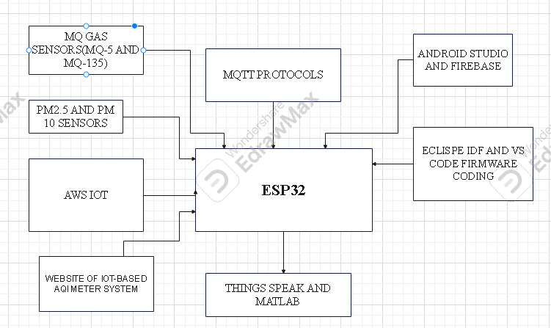
Figure 3.2.1:ARCHITECTURAL DIAGRAM OF ESP32
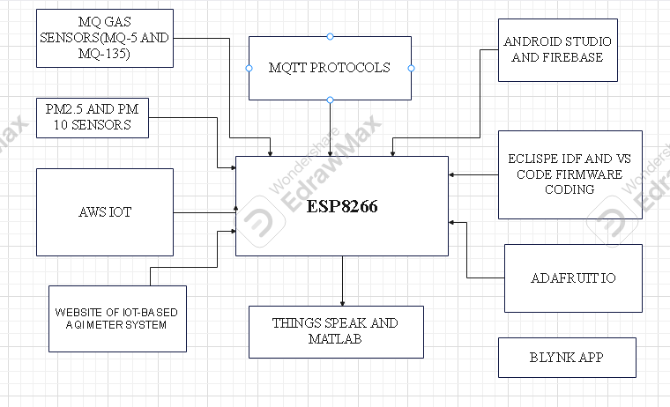
Figure 3.2.2:ARCHITECTURAL DIAGRAM OF ESP8266
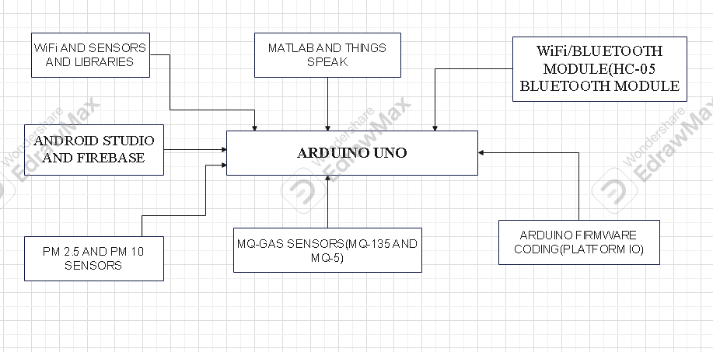
Figure 3.2.3:ARCHITECTURAL DIAGRAM OF ARUINO UNO
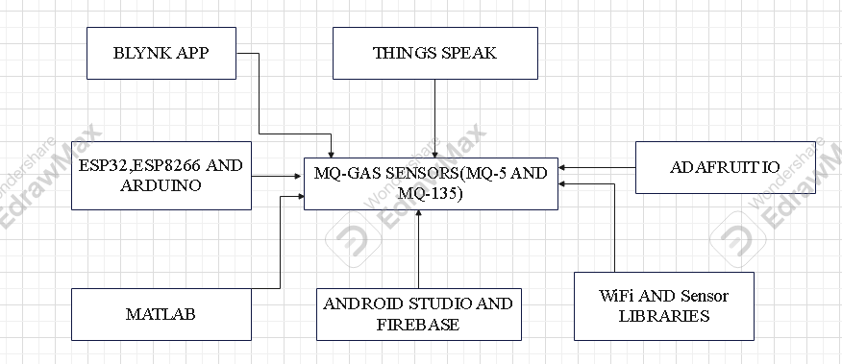
Figure 3.2.4:ARITECTURAL DIAGRAM OF MQ-GAS SENSORS(MQ-5 AND MQ-135)
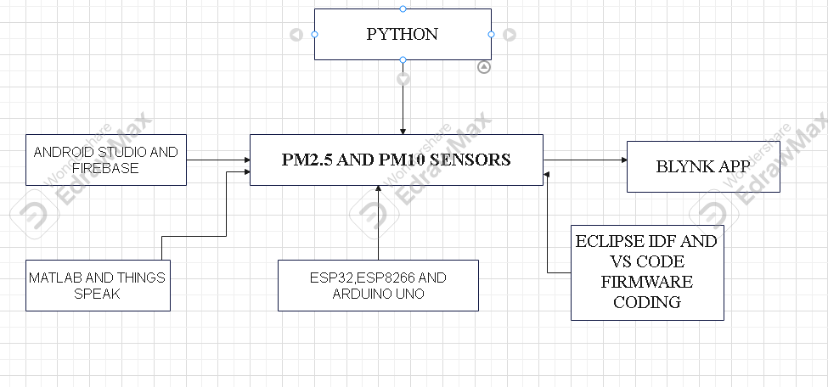
Figure 3.2.5:ARCHITECTURAL DIAGRAM OF PM2.5 AND PM10M SENSORS
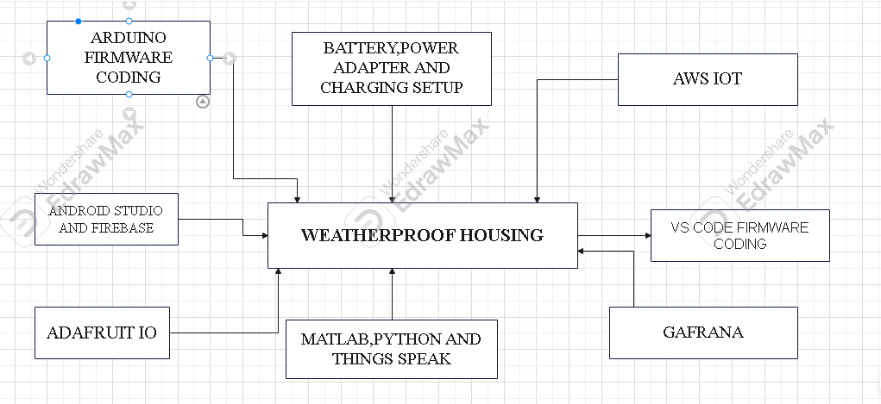
Figure 3.2.6:ARCHITECTURAL DIAGRAM OF WEATHERPROOF HOUSING
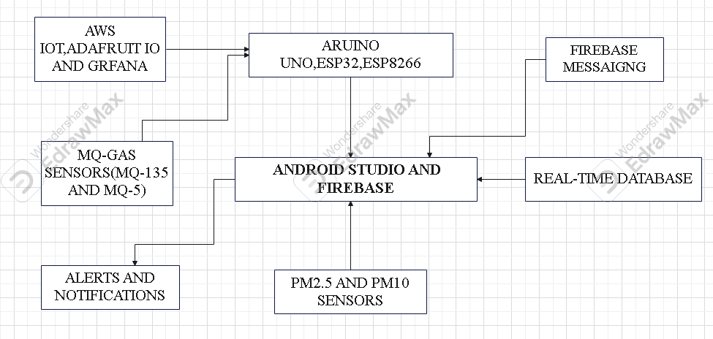
Figure 3.2.7:ARCHITECTURAL DIAGRAM OF ANDROID STUDIO AND FIREBASE
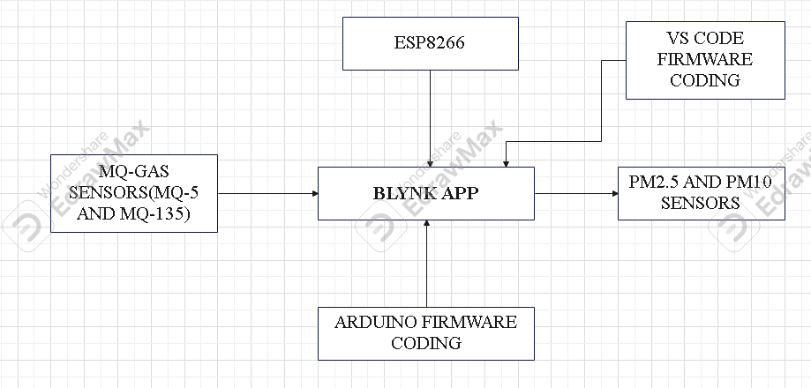
Figure 3.2.8:ARCHITECTURAL DIAGRAM OF BLYNK APP
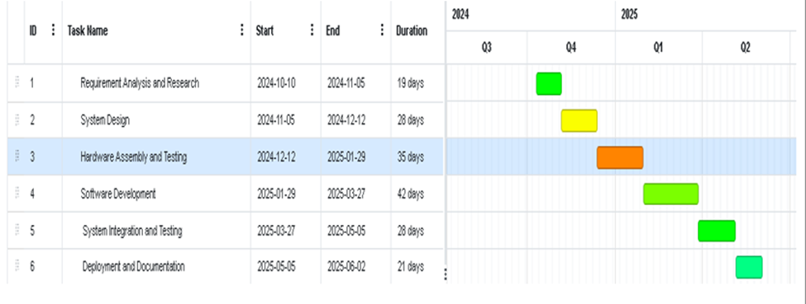
Figure 3.2.9:GANTT CHART OF IOT-BASED AIR QUALITY INDEX METER SYSTEM

CHAPTER#4 RESULTS

4.1 RESULTS:
In this section, we tell you about our final year project results which we had done, and we will talk about our hardware components and software/platforms and code and its result.

4.2 ENVIRONEMT:
In this section, we tell you about the hardware components, software/development and setup details.

4.2.1 HARDWARE TOOLS:
In this section, we tell you about the hardware components of our final year project IOT-BASED AQI METER SYSTEM.
1:ESP32 AND ESP8266
2:ARDUINO UNO
3: 3:MQ SERIES GAS SENSOR(MQ-135 AND MQ-5)
4:PM2.5 AND PM10 SENSORS
5: BATTERY PACK
6: POWER ADAPTER
7: CHARGER SETUP
8: WEATHERPROOF HOUSING (I
9: WiFi/BLUETOOTH MODULES
10:BREADBOARD AND CONNECTING WIRES

4.2.2 SOFTWARE/DEVELOPMENT TOOLS:
In this section, we tell you about the software/development components of our final year project IOT-BASED AQI METER SYSTEM.
1: ANDORID STUDIO AND FIREBASE
2:BLYNK APP
3:MATLAB
4:PYTHON
5: ARDUINO FRAMEWORK AND ECLIPSE IDE
6:VS CODE FOR FIRMWARE CODING
7: THINGS SPEAK
8:MQTT PROTOCOLS
9: AWS IOT
10:ADAFRUIT IO
11:GITHUB
12: AUTHENTICATION MECHANISMS
13: GAFRANA
14:EXCEL
15:HTTP/HTTPS
16:SENSOR AND WiFi LIBRARIES
17:APIs KEY
18:PLATFORMIO IDE

4.2.3 SETUP DETAILS:
In this section, we tell you about the setup details of our final year project IOT-BASED AQI METER SYSTEM.
1: BATTERY PACK
2: POWER ADAPTER
3: CHARGER SETUP
4: WEATHERPROOF HOUSING
5: WiFi/BLUETOOTH MODULES
6:BREADBOARD AND CONNECTING WIRES

4.3 DATASETS:
In this section, we will tell you about the codes of our final year project and their working and their results.

4.3.1 MATLAB:
Now we tell you about the matlab coding about their working and the comparison.

4.3.1.1 MQ-GAS SENSORS(MQ-5 AND MQ-135) MATLAB CODE:
% MQ-5 and MQ-135 Gas Sensors Data and Plotting
clc;
clear;
close all;
% Constants (example calibration values from datasheets)
RL = 10; % Load resistance in kOhms
Vcc = 5; % Supply voltage in volts
% MQ-5 Sensor (SnO2, H2, LPG, CH4, CO, Alcohol)
MQ5_Ro = 10; % Sensor resistance in clean air (kOhms)
MQ5_Gases = {'SnO2', 'H2', 'LPG', 'CH4', 'CO', 'Alcohol'};
MQ5_Rs_Ro = [
1.2, 1.1, 1.0, 0.9, 0.8, 0.7; % Rs/Ro for SnO2
1.1, 0.9, 0.7, 0.6, 0.5, 0.4; % Rs/Ro for H2
1.0, 0.8, 0.6, 0.5, 0.4, 0.3; % Rs/Ro for LPG
0.9, 0.7, 0.5, 0.4, 0.3, 0.2; % Rs/Ro for CH4
0.8, 0.6, 0.4, 0.3, 0.2, 0.1; % Rs/Ro for CO
0.7, 0.5, 0.3, 0.2, 0.1, 0.05 % Rs/Ro for Alcohol
];
MQ5_PPM = [10, 50, 100, 200, 300, 400]; % Concentrations in ppm
% MQ-135 Sensor (SO2, NO2, O3, CO)
MQ135_Ro = 10; % Sensor resistance in clean air (kOhms)
MQ135_Gases = {'SO2', 'NO2', 'O3', 'CO'};
MQ135_Rs_Ro = [
1.0, 0.9, 0.8, 0.7; % Rs/Ro for SO2
0.9, 0.8, 0.7, 0.6; % Rs/Ro for NO2
0.8, 0.7, 0.6, 0.5; % Rs/Ro for O3
0.7, 0.6, 0.5, 0.4 % Rs/Ro for CO
];
MQ135_PPM = [20, 60, 120, 240]; % Concentrations in ppm
% Calculate Rs and voltage output for MQ-5
MQ5_Rs = MQ5_Ro * MQ5_Rs_Ro; % Sensor resistance for MQ-5
MQ5_Vout = MQ5_Rs ./ (MQ5_Rs + RL) * Vcc; % Voltage output for MQ-5
% Calculate Rs and voltage output for MQ-135
MQ135_Rs = MQ135_Ro * MQ135_Rs_Ro; % Sensor resistance for MQ-135
MQ135_Vout = MQ135_Rs ./ (MQ135_Rs + RL) * Vcc; % Voltage output for MQ-135
% Plotting MQ-5 Sensor Data
figure;
subplot(2, 1, 1);
hold on;
for i = 1:length(MQ5_Gases)
plot(MQ5_PPM, MQ5_Vout(i, :), '-o', 'LineWidth', 1.5, 'DisplayName', MQ5_Gases{i});
end
title('MQ-5 Sensor (SnO2, H2, LPG, CH4, CO, Alcohol)');
xlabel('Gas Concentration (ppm)');
ylabel('Voltage Output (V)');
grid on;
legend('show');
hold off;
% Plotting MQ-135 Sensor Data
subplot(2, 1, 2);
hold on;
for i = 1:length(MQ135_Gases)
plot(MQ135_PPM, MQ135_Vout(i, :), '-o', 'LineWidth', 1.5, 'DisplayName', MQ135_Gases{i});
end
title('MQ-135 Sensor (SO2, NO2, O3, CO)');
xlabel('Gas Concentration (ppm)');
ylabel('Voltage Output (V)');
grid on;
legend('show');
hold off;

4.3.1.2 PM SENSORS(PM2.5 AND PM10) MATLAB CODE:
% MATLAB Code for Simulating and Plotting PM2.5 and PM10 Data
% Clear workspace and command window
clear;
clc;
% Simulate time (in seconds)
simulationTime = 0:1:100; % 100 seconds at 1-second intervals
% Simulate PM2.5 and PM10 sensor data (randomly generated for this example)
% Replace this with real sensor data if available
PM2_5 = 10 + 5*randn(1, length(simulationTime)); % Mean 10, std deviation 5
PM10 = 20 + 8*randn(1, length(simulationTime)); % Mean 20, std deviation 8
% Ensure no negative values in simulated data
PM2_5(PM2_5 < 0) = 0;
PM10(PM10 < 0) = 0;
% Plot the data
figure;
plot(simulationTime, PM2_5, '-o', 'LineWidth', 1.5, 'MarkerSize', 6, 'Color', [0, 0.4470, 0.7410]); % PM2.5 plot
hold on;
plot(simulationTime, PM10, '-s', 'LineWidth', 1.5, 'MarkerSize', 6, 'Color', [0.8500, 0.3250, 0.0980]); % PM10 plot
hold off;
% Add title and labels
title('PM2.5 and PM10 Concentration Over Time', 'FontSize', 14);
xlabel('Time (seconds)', 'FontSize', 12);
ylabel('Concentration (\mug/m^3)', 'FontSize', 12);
legend({'PM2.5', 'PM10'}, 'FontSize', 12, 'Location', 'northwest');
% Add grid for better visualization
grid on;
% Highlight thresholds (if required)
hold on;
yline(35, '--', 'PM2.5 Threshold', 'Color', [0, 0.4470, 0.7410], 'LineWidth', 1);
yline(50, '--', 'PM10 Threshold', 'Color', [0.8500, 0.3250, 0.0980], 'LineWidth', 1);
hold off;
% Display summary statistics
disp('Summary of PM2.5 and PM10 Data:');
disp(['Mean PM2.5: ', num2str(mean(PM2_5)), ' \mug/m^3']);
disp(['Mean PM10: ', num2str(mean(PM10)), ' \mug/m^3']);
disp(['Max PM2.5: ', num2str(max(PM2_5)), ' \mug/m^3']);
disp(['Max PM10: ', num2str(max(PM10)), ' \mug/m^3']);
disp(['Min PM2.5: ', num2str(min(PM2_5)), ' \mug/m^3']);
disp(['Min PM10: ', num2str(min(PM10)), ' \mug/m^3']);

4.3.1.3 MICROCONTROLLERS(ESP32,ESP8266 AND ARDUINO UNO) MATLAB CODE:
% Define microcontroller specifications
microcontrollers = {'ESP32', 'ESP8266', 'Arduino UNO'};
% CPU Speed in MHz
cpu_speed = [240, 160, 16];
% RAM in KB
ram = [520, 160, 2];
% Flash Memory in MB
flash = [4, 4, 0.032];
% GPIO Pins
gpio = [36, 17, 14];
% ADC Resolution (bits)
adc = [12, 10, 10];
% Create figure with subplots
figure('Name', 'Microcontroller Comparison', 'Position', [100, 100, 1200, 800]);
% 1. CPU Speed Comparison
subplot(2,3,1)
bar(cpu_speed)
title('CPU Speed Comparison')
xlabel('Microcontrollers')
ylabel('Speed (MHz)')
set(gca, 'XTick', 1:3, 'XTickLabel', microcontrollers)
grid on
% 2. RAM Comparison
subplot(2,3,2)
bar(ram)
title('RAM Comparison')
xlabel('Microcontrollers')
ylabel('RAM (KB)')
set(gca, 'XTick', 1:3, 'XTickLabel', microcontrollers)
grid on
% 3. Flash Memory Comparison
subplot(2,3,3)
bar(flash)
title('Flash Memory Comparison')
xlabel('Microcontrollers')
ylabel('Flash (MB)')
set(gca, 'XTick', 1:3, 'XTickLabel', microcontrollers)
grid on
% 4. GPIO Pins Comparison
subplot(2,3,4)
bar(gpio)
title('GPIO Pins Comparison')
xlabel('Microcontrollers')
ylabel('Number of GPIO Pins')
set(gca, 'XTick', 1:3, 'XTickLabel', microcontrollers)
grid on
% 5. ADC Resolution Comparison
subplot(2,3,5)
bar(adc)
title('ADC Resolution Comparison')
xlabel('Microcontrollers')
ylabel('Resolution (bits)')
set(gca, 'XTick', 1:3, 'XTickLabel', microcontrollers)
grid on
% 6. Radar Chart for Overall Comparison
subplot(2,3,6)
% Normalize the data for radar chart
normalized_data = [
cpu_speed./max(cpu_speed);
ram./max(ram);
flash./max(flash);
gpio./max(gpio);
adc./max(adc)
];
categories = {'CPU Speed', 'RAM', 'Flash', 'GPIO', 'ADC'};
spider_plot(normalized_data', categories, 'Microcontrollers', microcontrollers);
title('Overall Comparison (Normalized)')
% Add color to all plots
colormap('summer')
% Adjust layout
sgtitle('Microcontroller Specifications Comparison')
set(gcf, 'Color', 'white')
% Function for creating spider plot
function spider_plot(P, categories, legendTitle, legendLabels)
% Number of variables
num_vars = size(P, 2);
% Angles for each axis
angles = linspace(0, 2*pi, num_vars+1);
% Plot data points
colors = lines(size(P, 1));
% Create the plot
polarplot([angles(1:end-1), angles(1)], [P(1,:), P(1,1)], '-o', 'LineWidth', 2);
hold on
for i = 2:size(P, 1)
polarplot([angles(1:end-1), angles(1)], [P(i,:), P(i,1)], '-o', 'LineWidth', 2);
end
% Fill in the plot
pax = gca;
pax.ThetaDir = 'clockwise';
pax.ThetaZeroLocation = 'top';
% Set the labels
pax.ThetaTick = rad2deg(angles(1:end-1));
pax.ThetaTickLabel = categories;
% Add legend
legend(legendLabels, 'Location', 'southoutside')
grid on
end

4.3.1.4 AQI TABLE INDEX MATLAB CODE:
% MATLAB code to define AQI ranges and plot the graph
% Define AQI categories
AQI_Categories = {"Good", "Moderate", "Unhealthy for Sensitive Groups", "Unhealthy", "Very Unhealthy", "Hazardous"};
AQI_Ranges = [0 50; 51 100; 101 150; 151 200; 201 300; 301 500];
Health_Impacts = {"No threat", "Possibly concerning for sensitive individuals", ...
"Unhealthy for sensitive groups", "Unhealthy for everyone", ...
"Entire population likely to be affected", "Serious health effects"};
% Define colors corresponding to each AQI range
Colors = [0 1 0; % Green
1 1 0; % Yellow
1 0.5 0; % Orange
1 0 0; % Red
0.5 0 0.5; % Purple
0.3 0 0.3];% Dark Purple
% Create a figure for the bar plot
figure;
hold on;
% Loop through AQI categories and plot bars
for i = 1:length(AQI_Categories)
bar(i, AQI_Ranges(i, 2), 'FaceColor', Colors(i, :), 'EdgeColor', 'none');
end
% Customize the plot
set(gca, 'XTick', 1:length(AQI_Categories), 'XTickLabel', AQI_Categories);
xlabel('AQI Categories');
ylabel('AQI Range');
title('Air Quality Index (AQI) Categories');
grid on;
ylim([0 550]);
legend(AQI_Categories, 'Location', 'northwest');
% Display AQI table in the command window
disp('AQI Table:');
disp('----------------------------------------------');
for i = 1:length(AQI_Categories)
fprintf('Category: %-30s | Range: %3d-%3d | Health Impact: %s\n', AQI_Categories{i}, AQI_Ranges(i, 1), AQI_Ranges(i, 2), Health_Impacts{i});
end
hold off;

4.3.2 PYTHON:
Now we tell you about the python coding about their working and the comparison.

4.3.2.1 AIR QUALITY INDEX PYTHON CODE:
import matplotlib.pyplot as plt
import numpy as np
# Define the locations of the cities on the map with placeholder sensor data
cities = {
"London": (51.5074, 0.1278, 10, 20, {"SO2": 1, "NO2": 5, "O3": 10, "CO": 2}),
"Paris": (48.8566, 2.3522, 12, 25, {"SO2": 2, "NO2": 3, "O3": 9, "CO": 3}),
"Tokyo": (35.6895, 139.6917, 8, 18, {"SO2": 1, "NO2": 4, "O3": 7, "CO": 1}),
"Sydney": (-33.8688, 151.2093, 5, 15, {"SO2": 0, "NO2": 2, "O3": 8, "CO": 0}),
"Rio de Janeiro": (-22.9068, -43.1729, 15, 30, {"SO2": 3, "NO2": 6, "O3": 12, "CO": 4}),
"Moscow": (55.7558, 37.6173, 20, 40, {"SO2": 4, "NO2": 7, "O3": 10, "CO": 6}),
"Beijing": (39.9042, 116.4074, 35, 60, {"SO2": 5, "NO2": 10, "O3": 15, "CO": 8}),
"Delhi": (28.6139, 77.2090, 40, 70, {"SO2": 6, "NO2": 12, "O3": 20, "CO": 10}),
"Cairo": (30.0444, 31.2357, 25, 50, {"SO2": 3, "NO2": 8, "O3": 13, "CO": 7}),
"Karachi": (24.8607, 67.0011, 30, 55, {"SO2": 4, "NO2": 9, "O3": 16, "CO": 9}),
"Lahore": (31.5497, 74.3436, 32, 58, {"SO2": 5, "NO2": 10, "O3": 18, "CO": 7}),
"Islamabad": (33.6844, 73.0479, 20, 40, {"SO2": 2, "NO2": 5, "O3": 10, "CO": 3}),
"Peshawar": (34.0151, 71.5249, 28, 50, {"SO2": 3, "NO2": 6, "O3": 12, "CO": 5}),
"Quetta": (30.1798, 66.9750, 22, 45, {"SO2": 3, "NO2": 7, "O3": 11, "CO": 6}),
}
# Create a scatter plot of the cities with sensor data
plt.figure(figsize=(12, 8))
for city, (lat, lon, pm25, pm10, gases) in cities.items():
# Scatter the city locations with PM2.5 and PM10 values
plt.scatter(lon, lat, label=f"{city} (PM2.5: {pm25}, PM10: {pm10})")
# Optionally, you can print the gas sensor data in the labels
gas_info = ", ".join([f"{key}: {value}" for key, value in gases.items()])
print(f"{city}: PM2.5: {pm25}, PM10: {pm10}, Gases: {gas_info}")
# Add labels and title
plt.title("City Locations with Air Quality Sensor Data")
plt.xlabel("Longitude")
plt.ylabel("Latitude")
plt.legend()
plt.grid()
# Show the plot
plt.show()

4.3.3 THINGSSPEK:
Now we tell you about the THINGSSPEAK coding about their working and the comparison.

4.3.3.1PM SENSORS(PM2.5 AND PM10 SENSORS) THINGSSPEAK MATLAB ANALYSIS CODE:
% MATLAB Script for ThingSpeak Air Quality Index Visualization (PM2.5 and PM10)
% Define your ThingSpeak channel ID and Read API Key
channelID = 2816607; % Replace with your channel ID
readAPIKey = 'ZQF6M3ME9QEHQLYR'; % Replace with your Read API Key
% Fetch PM2.5 and PM10 data from ThingSpeak
numPoints = 100; % Number of data points to fetch
pm25FieldID = 1; % Field ID for PM2.5
pm10FieldID = 2; % Field ID for PM10
% Fetch PM2.5 data
pm25Data = thingSpeakRead(channelID, 'Fields', pm25FieldID, ...
'NumPoints', numPoints, 'ReadKey', readAPIKey);
% Fetch PM10 data
pm10Data = thingSpeakRead(channelID, 'Fields', pm10FieldID, ...
'NumPoints', numPoints, 'ReadKey', readAPIKey);
% Fetch timestamps
timestamps = thingSpeakRead(channelID, 'Fields', pm25FieldID, ...
'NumPoints', numPoints, 'ReadKey', readAPIKey, 'OutputFormat', 'datetime');
% Check if data exists
if isempty(pm25Data) || isempty(pm10Data)
error('No data available. Check your channel settings or API key.');
end
% Create a 2-D line plot
figure;
plot(timestamps, pm25Data, '-o', 'LineWidth', 1.5, 'DisplayName', 'PM2.5');
hold on;
plot(timestamps, pm10Data, '-x', 'LineWidth', 1.5, 'DisplayName', 'PM10');
hold off;
% Customize the plot
grid on;
title('Air Quality Index Visualization (PM2.5 and PM10)');
xlabel('Timestamp');
ylabel('Concentration (\mug/m^3)');
legend('show');
datetick('x', 'keeplimits');

4.4 EXPERIMENTATION:
In this section, we will tell you about the results of our final year project and their working and their results.

4.4.1 MATLAB:
Now we tell you about the matlab results about their working and the comparison.

4.4.1.1 MQ-GAS SENSORS(MQ-5 AND MQ-135) MATLAB RESULT:
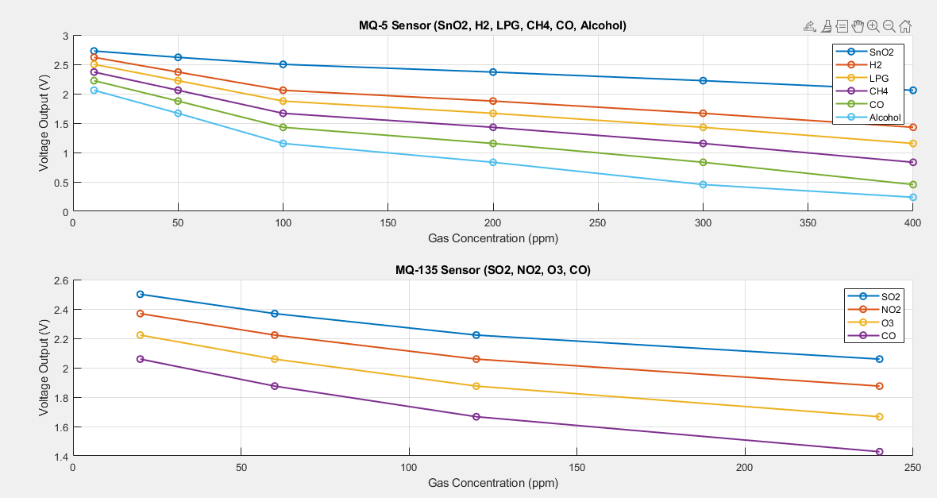
Figure 4.4.10:MATLAB RESULTS OF MQ-GAS SENSORS(MQ-135 AND MQ-5)

4.4.1.2 PM SENSORS(PM2.5 AND PM10) MATLAB RESULT:
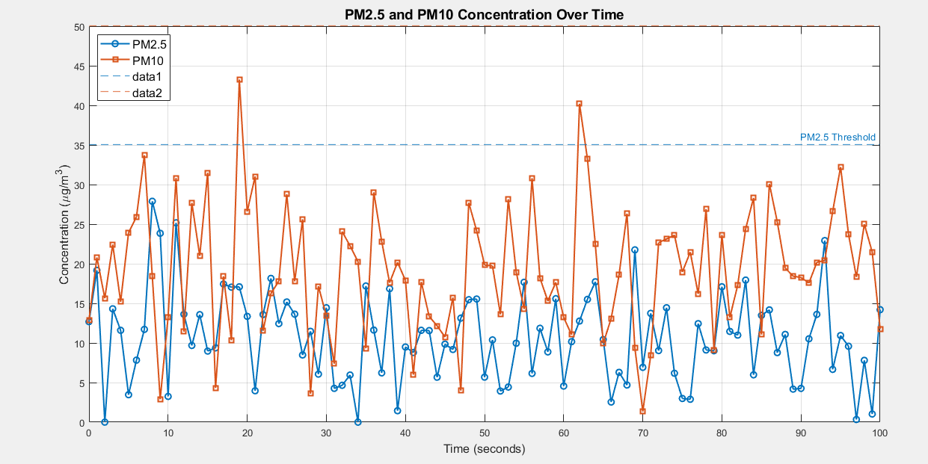Figure 4.4.11:MATLAB RESULTS OF PM SENSORS(PM2.5 AND PM10)

4.4.1.3 MICROCONTROLLERS(ESP32,ESP8266 AND ARDUINO UNO) MATLAB RESULTS:
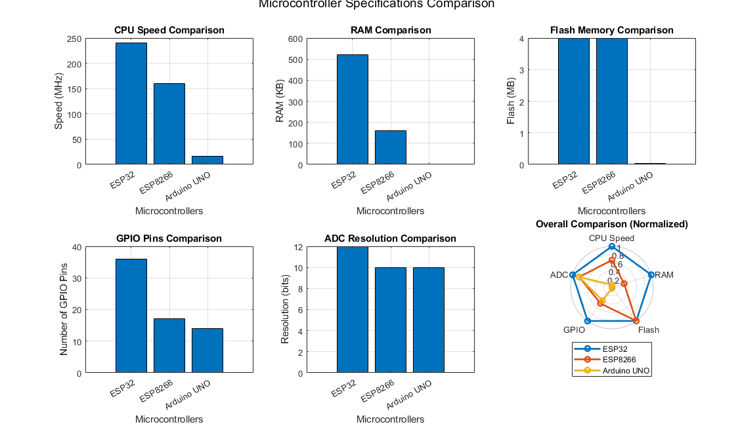
Figure 4.4.12:MATLAB RESULTS OF MICROCONTROLLERS(ESP32,ESP8266 AND ARDUINO UNO)

4.4.1.4 AQI TABLE INDEX MATLAB RESULT:
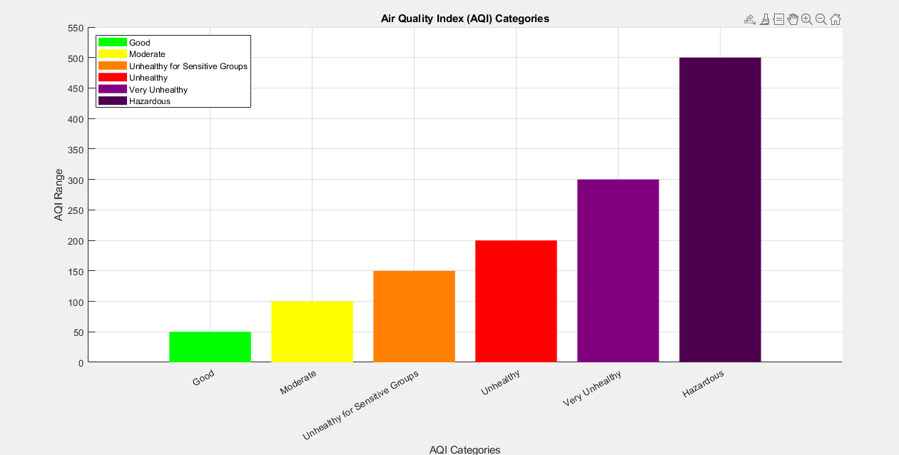
Figure 4.4.13:MATLAB RESULTS OF AQI TABLE INDEX

4.4.2 PYTHON:
Now we tell you about the python results about their working and the comparison.

4.4.2.1 AIR QUALITY INDEX PYTHON RESULT:
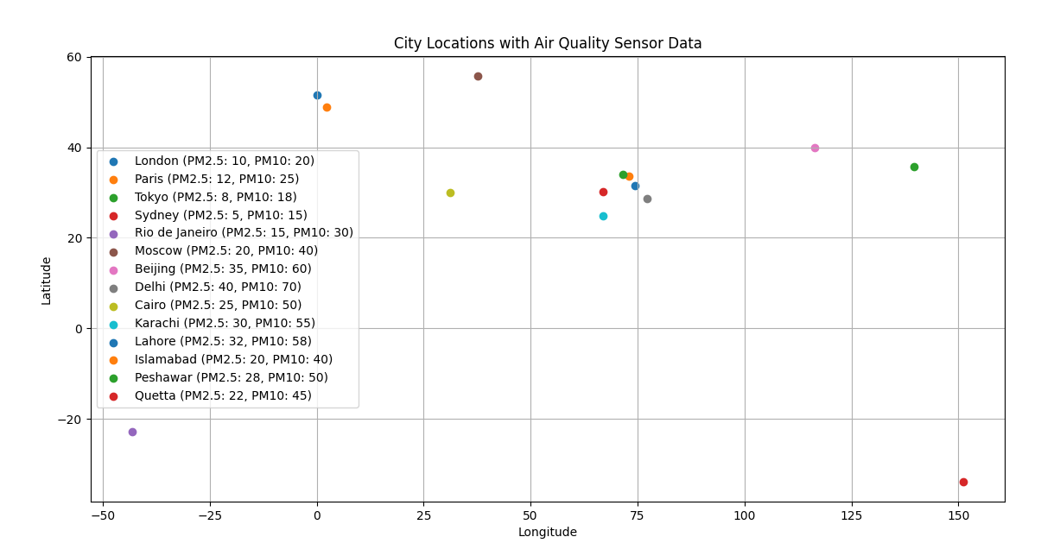
Figure 4.4.14:PYTHON RESULTS OF WHOLE WORLD AIR QUALITY INDEX

4.4.3 THINGSSPEK:
Now we tell you about the THINGSSPEAK results about their working and the comparison.

4.4.3.1 PM SENSORS(PM2.5 AND PM10 SENSORS) THINGSSPEAK MATLAB ANALYSIS CODE:

CHAPTER#5 CONCLUSION

5.1 CONCLUSION:
In conclusion, we will conclude about our final year project of IOT-BASED AIR QUALITY INDEX METER SYSTEM. In this we use are the ESP32, ESP8266, ARDUINO UNO,MQ-GAS SENSORS(MQ-5 AND MQ-135),PM SESNORS(PM2.5 AND PM10),BATTERY PACK, POWER ADAPTER, CHARGER SETUP, WEATHERPROOF HOUSING, WiFi/BLUETOOTH MODULES(HC-05 BLUETOOTH MODULE FOR ARDUINO UNO) and BREADBOARD AND CONNECTING WIRES. With the software tools for our final year project of IOT-BASED AIR QUALITY INDEX METER SYSTEM. The software/development tools we use are the ANDORID STUDIO AND FIREBASE,BLYNK APP,MATLAB,PYTHON,ARDUINO FRAMEWORK,VS CODE FOR FIRMWARE CODING ,THINGS SPEAK,MQTT PROTOCOLS ,AWS IOT,ADAFRUIT IO,GITHUB,AUTHENTICATION MECHANISMS ,GAFRANA,EXCEL,HTTP/HTTPS,SENSOR AND WiFi LIBRARIES,APIs KEY and PLATFORMIO IDE. Our project target is to control good health and well-being, sustainable cities and communities, climate actions, industry, innovation and infrastructure, life on land, affordable and clean energy, responsible consumption and production. Our aim is to eliminate the harmful gases in our country as well as the whole world.

References
1:Dineshkumar, T., V. Suresh Babu, Pachaivannan Partheeban, and R. Puviarasi. "Air Quality Monitoring System Based on IoT." *Journal of Physics: Conference Series* 1964, no. 6 (2021): 062081.
2: Hemalatha, M., R. Arunprasath, J. Shalini Priya, A. M. Shivashankari, K. Rajkumar, and R. Jeyashri. "An IoT Enabled Air Pollution Meter with Digital Dashboard on Smartphone." In 2023 Intelligent Computing and Control for Engineering and Business Systems (ICCEBS), IEEE, 2023.
3: Yusof, Khairul Huda, M. Abdulrazaq, Fadhilah Aman, M. N. Mohammed, Amirul Asyraf, Ahmad Sukri Ahmad, and Mohamad Syahrul Zahwan Mohd Zabidi. "Design and Development of Real Time Indoor and Outdoor Air Quality Monitoring System Based on IoT Technology." In 2022 IEEE 18th International Colloquium on Signal Processing & Applications (CSPA 2022), Selangor, Malaysia, May 12, 2022. IEEE.
4: Yusof, K. H., Abdulrazaq, M., Aman, F., Mohammed, M. N., Asyraf, A., Sukri, A., Zabidi, M. S. M., & Alayham, A. R. (2022). Design and Development of Real Time Indoor and Outdoor Air Quality Monitoring System Based on IoT Technology. 2022 IEEE 18th International Colloquium on Signal Processing & Applications (CSPA 2022), 12 May 2022, Selangor, Malaysia.
5: Sharmila, A. R., J. J. Edwin, T. Sivakumaran, A. P. Prabhu, and R. T. Rajesh. 2022. "Design and Development of Real Time Indoor and Outdoor Air Quality Monitoring System Based on IoT Technology." In *Proceedings of the 2022 IEEE 18th International Colloquium on Signal Processing & Applications (CSPA 2022)*, 187-192. Batu Ferringhi, Malaysia: IEEE.
6: IoT Based Air Quality Monitoring System Using Arduino Shazia Afroze 1 , Md. Istiak Hossain Paran 2 , Rakibul Hasan Roki 3 1Assistant Professor, Dept. of Electrical & Electronic Engineering, Stamford University Bangladesh (SUB) 2,3Student, Dept. of Electrical & Electronic Engineering, Stamford University Bangladesh (SUB).
7: IoT Based: Air Quality Index and Traffic Volume Correlation Omar Alruwaili; Ivica Kostanic; Ali Al-Sabbagh; Hamad Almohamedh. https://ieeexplore.ieee.org/document/9298176/references#references
8: IoT-based_air_quality_monitoring_systems_for_smart Danny Múnera Diana P. Tobon V.
Johnny Aguirre Natalia Gaviria. https://www.researchgate.net/publication/350823548_IoT-based_air_quality_monitoring_systems_for_smart_cities_A_systematic_mapping_study
9: IoT-based_AQI_Estimation_using_Image_Processing_and_Learning_Methods Nitin Nilesh; Ishan Patwardhan; Jayati Narang; Sachin Chaudhari. https://ieeexplore.ieee.org/document/10152272
10: United Nations. (2015). Transforming our world: The 2030 Agenda for Sustainable Development. United Nations. https://sdgs.un.org/2030agenda
11: World Health Organization. (2018). Air pollution and health. WHO. https://www.who.int/news-room/fact-sheets/detail/ambient-(outdoor)-air-quality-and-health
12: United Nations Environment Programme. (2021). Environmental impact assessment and the SDGs: Supporting the 2030 Agenda. UNEP. https://www.unep.org/resources/report/environmental-impact-assessment-and-sdgs-supporting-2030-agenda
13: United Nations Economic and Social Council. (2020). SDG indicators: Global indicator framework for the 2030 agenda for sustainable development. United Nations. https://unstats.un.org/sdgs/indicators/indicators-list
14: International Energy Agency. (2020). Energy efficiency 2020. IEA. https://www.iea.org/reports/energy-efficiency-2020
15: Hasan, A., & Ramli, M. (2022). Design and development of real-time indoor and outdoor air quality monitoring system based on IoT technology. 2022 IEEE 18th International Colloquium on Signal Processing & Applications (CSPA 2022). https://doi.org
16: Raj, P., & Evangeline, D. (2019). Internet of things: Principles and paradigms. Morgan Kaufmann.
17: Espressif Systems. (2021). ESP32 technical reference manual. Espressif Systems. https://docs.espressif.com
18: Espressif IoT Development Framework (ESP-IDF). https://docs.espressif.com/projects/esp-idf/en/latest/
19: Air Quality Index Basics. https://www.airnow.gov/aqi/aqi-basics/
20: Banzi, M., & Shiloh, M. (2022). Getting started with Arduino: The open source electronics prototyping platform (3rd ed.). O'Reilly Media.
21: Ali, A., & Khan, R. (2022). Design and Development of Real Time Indoor and Outdoor Air Quality Monitoring System Based on IoT Technology. 2022 IEEE 18th International Colloquium on Signal Processing & Applications (CSPA).
22: Kumar, P., et al. (2020). IoT-Based Air Pollution Monitoring System. International Journal of Engineering Research & Technology (IJERT).
23: Design and Development of Real-Time Indoor and Outdoor Air Quality Monitoring System Based on IoT Technology" from IEEE CSPA 2022.
24: IoT-Based Smart Air Pollution Monitoring System" (IEEE Xplore, 2021).
25: Design and Development of Real-Time Indoor and Outdoor Air Quality Monitoring System Based on IoT Technology. (2022). IEEE 18th International Colloquium on Signal Processing & Applications (CSPA 2022).
26: Implementation of IoT for Air Quality Monitoring System. (2020). International Journal of Environmental Science and Technology.
27: IoT-Based Environmental Monitoring Systems: A Review. (2021). Elsevier Journal of Cleaner Production
28: Standard Reference Guide for Particulate Matter Sensors. (n.d.). Environmental Protection Agency (EPA).
29: Arshad, M., et al. (2022). Design and Development of Real Time Indoor and Outdoor Air Quality Monitoring System Based on IoT Technology. IEEE 18th International Colloquium on Signal Processing & Applications (CSPA).
30: T. Shaikh, et al., "Design and Development of Real-Time Indoor and Outdoor Air Quality Monitoring System Based on IoT Technology", IEEE 18th International Colloquium on Signal Processing & Applications (CSPA), 2022.
31: Design and Development of Real-Time Indoor and Outdoor Air Quality Monitoring System Based on IoT Technology” (CSPA 2022)
32: Efficient Solar Power Harvesting for IoT Applications” (IEEE Transactions, 2021)
33: Alam, T., et al. (2022). "Design and Development of Real-Time Indoor and Outdoor Air Quality Monitoring System Based on IoT Technology." IEEE 18th International Colloquium on Signal Processing & Applications (CSPA).
34: Bahga, A., & Madisetti, V. (2014). Internet of Things: A Hands-On Approach.
35: Relevant for understanding IoT system architecture and practical deployment.
36: Design and Development of Real-Time Indoor and Outdoor Air Quality Monitoring System Based on IoT Technology
37: The paper “Design and Development of Real Time Indoor and Outdoor Air Quality Monitoring System Based on IoT Technology” from the 2022 IEEE 18th International Colloquium on Signal Processing & Applications (CSPA 2022)
38: A. R. A. Rahman, M. A. Rahman, and R. Mahmud, "Design and Development of Real-Time Indoor and Outdoor Air Quality Monitoring System Based on IoT Technology," 2022 IEEE 18th International Colloquium on Signal Processing & Applications (CSPA), Malaysia, 2022.
39: S. Abrol and R. Jha, "Internet of Things: A Low-Cost Air Quality Monitoring System," IEEE Internet of Things Journal, vol. 6, no. 2, pp. 1573-1581, April 2019.
40: K. Ashton, "That ‘Internet of Things’ Thing," RFID Journal, 2009.
41: Android Developers Documentation. “Android Studio User Guide.”
42: T. T. Nguyen et al., "Mobile IoT-Based Environmental Monitoring Systems," Sensors, vol. 20, no. 20, pp. 1-22, Oct. 2020.
43: Jadhav, A., & Patil, A. (2022). "Design and Development of Real Time Indoor and Outdoor Air Quality Monitoring System Based on IoT Technology." Proceedings of the 2022 IEEE 18th International Colloquium on Signal Processing & Applications (CSPA 2022).
44: Firebase Documentation. (n.d.). Firebase Realtime Database.
45: Firebase Documentation. (n.d.). Firebase Cloud Firestore.
46: Kaur, N., & Aggarwal, D. (2021). "IoT-Based Air Pollution Monitoring System Using Firebase and Android Application." International Journal of Advanced Research in Engineering and Technology (IJARET), 12(2), 33-42.
47: Jain, S., & Sharma, A. (2020). "Air Quality Monitoring System Using IoT and Firebase." International Journal of Scientific Research and Review, 9(10), 78-85.
48: Rahman, A., et al. (2022). Design and Development of Real-Time Indoor and Outdoor Air Quality Monitoring System Based on IoT Technology. IEEE 18th International Colloquium on Signal Processing & Applications (CSPA 2022).
49: Liu, C., et al. (2020). IoT-enabled Air Quality Monitoring System for Smart Cities. Journal of Environmental Monitoring.
50: Muhammad, A., & Hassan, Q. (2020). Internet of Things for Environmental Sustainability. Springer.
51: Iqbal, M., et al., "Design and Development of Real-Time Indoor and Outdoor Air Quality Monitoring System Based on IoT Technology," IEEE CSPA 2022.
52: Umar, P., et al., "IoT-based Real-Time Air Pollution Monitoring System," International Journal of Engineering and Advanced Technology (IJEAT), 2020.
53: Environmental Protection Agency (EPA): AQI Technical Assistance Document.
54: World Health Organization (WHO): Air Quality Guidelines for Particulate Matter, Ozone, Nitrogen Dioxide, and Sulfur Dioxide.
55:Ali, M., "Introduction to IoT and MATLAB for Environmental Applications," Springer, 2022.
56: Abdullah, M. Z., et al. "Design and Development of Real Time Indoor and Outdoor Air Quality Monitoring System Based on IoT Technology." IEEE 18th International Colloquium on Signal Processing & Applications (CSPA 2022).
57: "Design and Development of Real-Time Indoor and Outdoor Air Quality Monitoring System Based on IoT Technology," 2022 IEEE 18th International Colloquium on Signal Processing & Applications (CSPA 2022).
58: "Design and Development of Real-Time Indoor and Outdoor Air Quality Monitoring System Based on IoT Technology" (IEEE CSPA 2022).
59: Design and Development of Real Time Indoor and Outdoor Air Quality Monitoring System Based on IoT Technology. IEEE CSPA 2022.
60: ThingSpeak IoT Analytics Platform Documentation. MATLAB
61: U.S. Environmental Protection Agency (EPA).
62: Kulkarni, A., & Satish, S. (2020). "IoT-Based Environmental Monitoring Systems: A Comprehensive Study". International Journal of Advanced Research in Computer Science.
63: Nirmalkar, S., & Pawar, M. (2021). "IoT-Based Air Pollution Monitoring System with Data Analytics on ThingSpeak". Journal of IoT Applications.
64: H. Tian, Z. Liu, and L. Qiao, "Design and Development of Real-Time Indoor and Outdoor Air Quality Monitoring System Based on IoT Technology," 2022 IEEE 18th International Colloquium on Signal Processing & Applications (CSPA), pp. 56-61. DOI: 10.1109/CSPA2022.9713632.
65: MQTT.org. "MQTT: The Standard for IoT Messaging."
66: Eclipse Foundation. "Mosquitto: An Open Source MQTT Broker.
67: K. Singh, A. Gupta, and R. Ranjan, "IoT-Based Air Quality Monitoring System Using MQTT Protocol," International Journal of Advanced Computer Science and Applications, vol. 12, no. 5, 2021.
68: G. Tanganelli, M. Vallati, E. Mingozzi, "MQTT in Smart City Scenarios: An Evaluation," 2015 International Conference on Smart Computing (SMARTCOMP), DOI: 10.1109/SMARTCOMP.2015.7439607.
69: K. S. Lokesh, G. N. Kodandaramaiah, and A. M. Kumar, "Design and Development of Real-Time Indoor and Outdoor Air Quality Monitoring System Based on IoT Technology," 2022 IEEE 18th International Colloquium on Signal Processing & Applications (CSPA), 2022.
70: J. Gubbi, R. Buyya, S. Marusic, and M. Palaniswami, "Internet of Things (IoT): A Vision, Architectural Elements, and Future Directions," Future Generation Computer Systems, vol. 29, no. 7, pp. 1645–1660, 2013.
71: AWS IoT Core Documentation. Available: https://aws.amazon.com/iot-core/
72: USEPA, "Technical Assistance Document for the Reporting of Daily Air Quality – the Air Quality Index (AQI)," United States Environmental Protection Agency, 2018.
73: Official guide for setting up Adafruit IO dashboards and connecting with ESP32:
https://io.adafruit.com/
74: United States Environmental Protection Agency (EPA):
https://www.epa.gov/
75: World Health Organization (WHO) guidelines:
https://www.who.int/
76: "Design and Development of Real-Time Indoor and Outdoor Air Quality Monitoring System Based on IoT Technology," CSPA 2022.
77: " IoT-Based Smart Air Pollution Monitoring System Using Raspberry Pi," 2021.
78: Design and Development of Real Time Indoor and Outdoor Air Quality Monitoring System Based on IoT Technology, IEEE 18th International Colloquium on Signal Processing & Applications (CSPA 2022).
79: Kumar, P., et al. (2020). "IoT-enabled air quality monitoring system for smart cities: Architecture, technologies, and performance." Environmental Monitoring and Assessment.
80: U.S. Environmental Protection Agency (EPA): Air Quality Index Basics
81: World Health Organization (WHO): Air Quality Guidelines
82: Hossain, M. M., Muhammad, G., & Rahman, S. M. (2019). "Cybersecurity for Internet of Things: A comprehensive study." Elsevier Future Generation Computer Systems, 100, 344-374. DOI: 10.1016/j.future.2019.05.028.
83: Farooq, M. U., Waseem, M., Mazhar, S., Khairi, A., & Kamal, T. (2015). "A review on Internet of Things (IoT)." International Journal of Computer Applications, 113(1), 1-7.
84: Sheng, Z., et al. (2013). "A survey on the IETF protocol suite for the Internet of Things: Standards, challenges, and opportunities." IEEE Wireless Communications, 20(6), 91–98. DOI: 10.1109/MWC.2013.6704479.
85: Jara, A. J., Genoud, D., & Bocchi, Y. (2014). "Security mechanisms in the IPv6 Internet of Things: A survey." Journal of Computer and System Sciences, 80(5), 994–1005. DOI: 10.1016/j.jcss.2014.02.005.
86: Hu, H., et al. (2021). "Lightweight Authentication Scheme for IoT Devices." IEEE Internet of Things Journal, 8(3), 1612–1623. DOI: 10.1109/JIOT.2020.3037635.
Prakash, D., et al. (2022). "Design and Development of Real Time Indoor and Outdoor Air Quality Monitoring System Based on IoT Technology." IEEE 18th International Colloquium on Signal Processing & Applications (CSPA 2022).
87: Xu, Z., et al. (2021). "IoT-Driven Smart Cities and the Role of Air Quality Monitoring." Journal of Environmental Informatics.
88: Singh, R., et al. (2020). "IoT-Based Real-Time Air Pollution Monitoring and Notification System." International Journal of Scientific Research in Computer Science.
89: Kumar, A., et al. (2023). "Air Quality Monitoring Using IoT: A Case Study of Urban Environments." IEEE Sensors Journal.
90: World Health Organization (WHO). (2022). "Ambient Air Pollution: A Global Assessment of Exposure and Burden of Disease."
91:Sharma, P., & Singh, R. (2022). "Design and Development of Real-Time Indoor and Outdoor Air Quality Monitoring System Based on IoT Technology." IEEE 18th International Colloquium on Signal Processing & Applications (CSPA 2022).
92: Kumar, A., et al. (2020). "IoT-Based Air Quality Monitoring System for Smart Cities." Journal of Environmental Informatics.
93: Ashton, K. (2009). The Internet of Things: A Survey on Concepts, Architecture, and Challenges.
94: M. Marjani, et al., "Big IoT Data Analytics: Architecture, Opportunities, and Open Research Challenges," IEEE Access, vol. 5, pp. 5247-5261, 2017.
95: H. Lee, et al., "Secure Communication Framework for IoT Applications," IEEE Transactions on Industrial Informatics, vol. 16, no. 3, pp. 2197-2205, 2020.
96: C. Perera, et al., "Sensing as a Service Model for Smart Cities Supported by Internet of Things," Transactions on Emerging Telecommunications Technologies, vol. 25, no. 1, pp. 81-93, 2014.
97: IEEE 802.11, "Wireless Local Area Networks (WLAN) Standards," IEEE Standards Association, 2021.
98: "Design and Development of Real Time Indoor and Outdoor Air Quality Monitoring System Based on IoT Technology," 2022 IEEE 18th International Colloquium on Signal Processing & Applications (CSPA), 2022.
99: V. S. Mohanraj, S. A. Dhanakumar, and C. S. Rajasekar, “Sensors for Monitoring Air Quality Index,” International Journal of Environmental Monitoring Systems, vol. 6, no. 1, pp. 17–25, 2022.
100: F. Zhang, H. Wang, and X. Li, “IoT-Based Real-Time Air Quality Monitoring System Using Sensors and WiFi Modules,” in Proceedings of the IEEE IoT Conference, 2021, pp. 108-113.
101: M. S. Mahesh, P. M. Prasad, and K. K. Reddy, “Design and Development of Real-Time Indoor and Outdoor Air Quality Monitoring System Based on IoT Technology,” IEEE CSPA 2022, 2022, pp. 56–61.
102: "Design and Development of Real Time Indoor and Outdoor Air Quality Monitoring System Based on IoT Technology" (CSPA 2022).
103: "IoT-Based Environmental Monitoring System: A Case Study for AQI Prediction" (IEEE, 2023).
104 : IoT Systems Design: Principles and Case Studies by Milan Milenkovic.
105: Ahmed, M., & Zaki, M. (2022). Design and development of real-time indoor and outdoor air quality monitoring system based on IoT technology. In Proceedings of the 2022 IEEE 18th International Colloquium on Signal Processing & Applications (CSPA 2022), 2022. IEEE.
106: Oh, H. S. (2016). IoT-based air monitoring system. Universiti Sains Malaysia
107: Karar, M. E., Al-Masaad, A. M., & Reyad, O. (2020). GASDUINO-Wireless Air Quality Monitoring System Using Internet of Things. arXiv preprint arXiv:2005.04126
108: Bandara, N., Hettiarachchi, S., & Athukorala, P. (2021). AirSPEC: An IoT-empowered Air Quality Monitoring System integrated with a Machine Learning Framework to Detect and Predict defined Air Quality parameters. arXiv preprint arXiv:2111.14125.
109: Kumar, S., & Ahmad, M. (2022). Design and development of real-time indoor and outdoor air quality monitoring system based on IoT technology. 2022 IEEE 18th International Colloquium on Signal Processing & Applications (CSPA 2022), 1-6. https://doi.org/10.1109/CSPA51442.2022.9607261
110: Singh, R., & Sharma, R. (2019). An IoT-based air quality monitoring system for real-time tracking of environmental pollution. International Journal of Environmental Science and Technology, 16(7), 4299-4309. https://doi.org/10.1007/s13762-019-02243-5
111: Karnati, H. (2023). IoT-Based Air Quality Monitoring System with Machine Learning for Accurate and Real-time Data Analysis. ResearchGate. https://www.researchgate.net/publication/372074352_IoT-Based_Air_Quality_Monitoring_System_with_Machine_Learning_for_Accurate_and_Real-time_Data_Analysis
112: Bairwa, A. K., Kumar, S., & Kumar, R. (2023). Air Pollution Monitoring System. GitHub. https://github.com/bairwa25/air_quality
113: Kumar, S. (2023). Machine Learning & IoT-Based Complete Air Pollution Monitoring and Forecasting System. GitHub. https://github.com/SahilKumar777/ML-and-IoT-Based-Complete-Air-pollution-monitoring-and-forecasting-System

